Adding & Managing Domain Names
Log into your account. Afterwards, you’ll see your control panel. When you’re there, look to “Domain Management” and find the “Domain Setup” icon. Here you can add another domain.

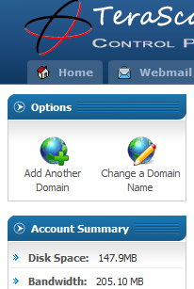
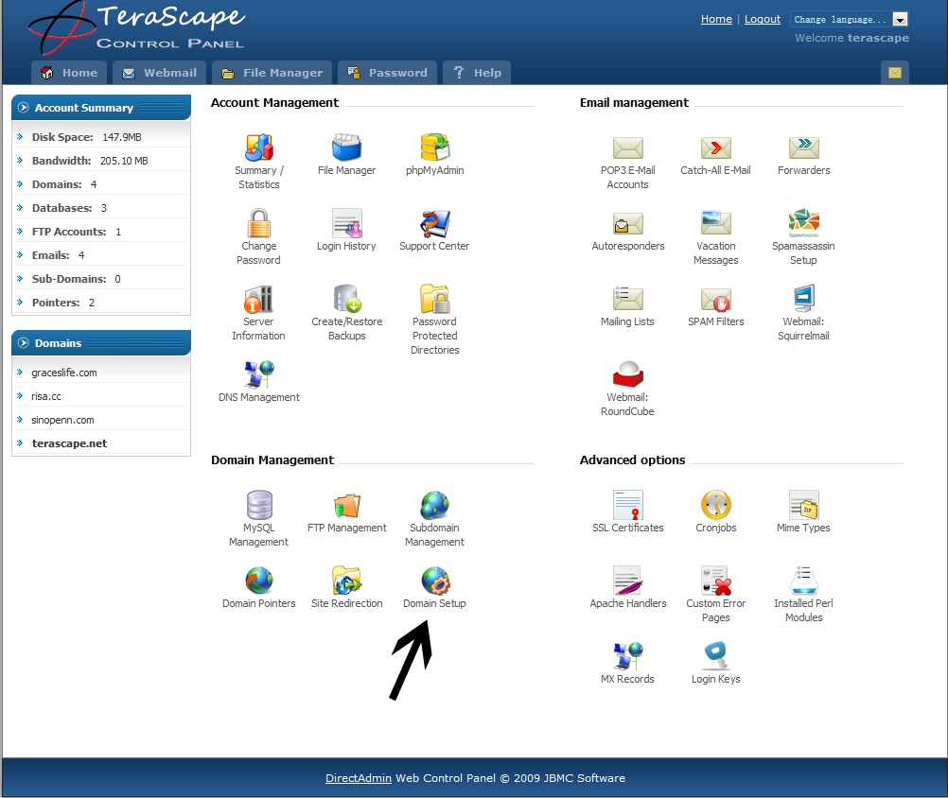
Click on “Add Another Domain” on the top left, and add your new domain name. When you come back, you’ll see your list of domains.
Note: When you do this, everytime you log in hereafter, you’ll first see your list of domains, rather than the main Control Panel. Select the domain name you want to work with.

Using the Temporary URL:
Now return to “Domain Setup” and SELECT the domain name you want to have as your Default. If you have not yet bought the domain name you added, you can go to http://123.254.108.246/~yourusername , you will see that domain under the temporary url. Please remember, when working with some CMS’s such as Wordpress, when the site goes live, you’ll have to update your settings to tell where wordpress should look for the site, i.e. www.yourdomain.com rather than http://123.254.108.246/~yourusername.

