Accessing your site & Uploading Files:
You can use any FTP client to upload to your site, as well as the server's built-in File Manager. On the control panel, both under "Domain Management" and the 3rd tab at the top, you'll find the File Manager. This allows you to upload or archive what you have already uploaded. It's also handy to execute .tgz files (downloaded CMS, PHP programs & such).

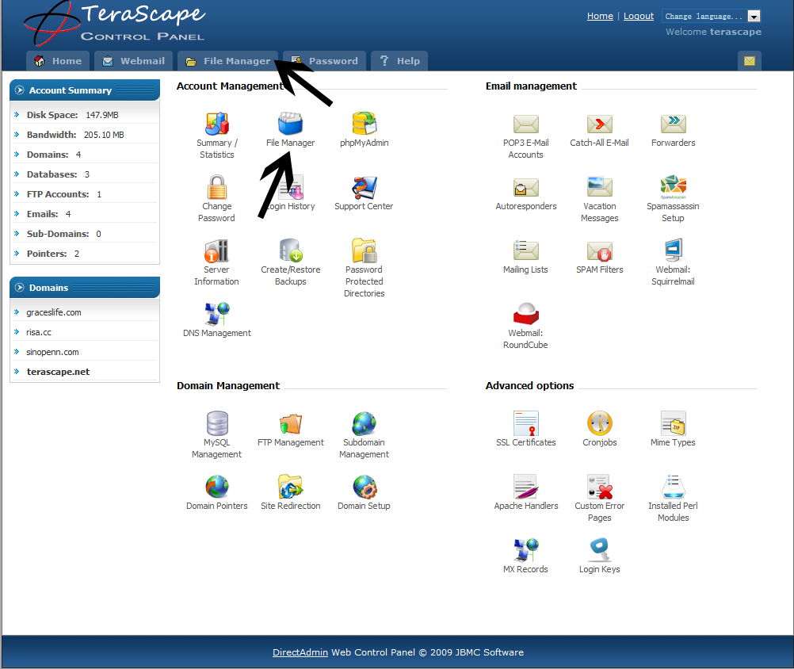

Remember, TeraScape uses Linux as it's operating system. Microsoft databases or .asp.net applications will not function. PHP is far more secure and advanced, and is the standard of some of the biggest, best websites on the internet.

For FTP (File Transfer Protocol):
This information is for wsFTP, Dreamweaver, FileZilla and other ftp or site building clients.
login: your control panel login (in lowercase letters)
pass: your password
server: 123.254.108.246
port: 21 (some programs do not ask for port.)

Alternatively, you can create a separate username for FTP access. Create that under “FTP sub-accounts & choose which folder you want that user to have access to. Default is the entire account, so beware of what access you give to whom.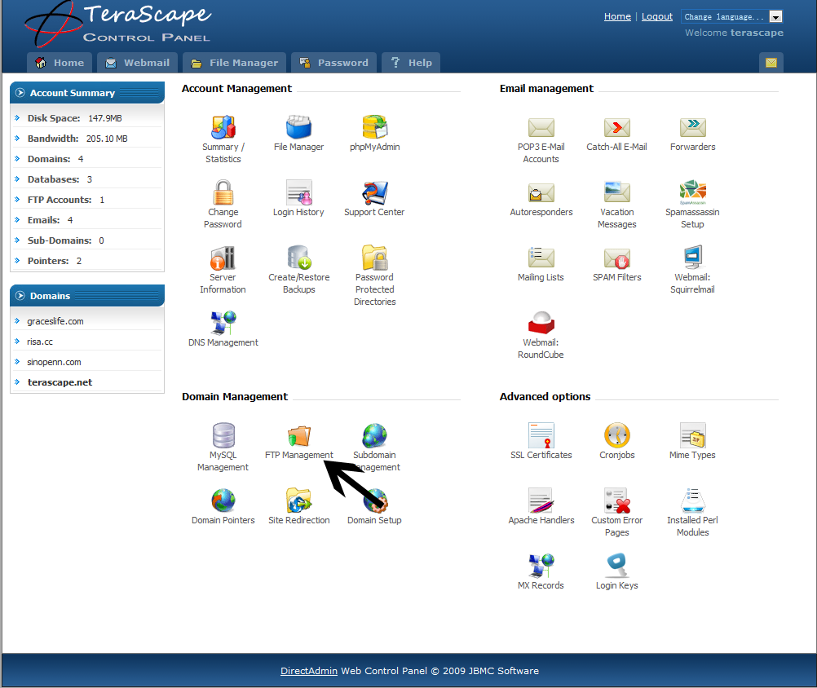

Creating a new FTP user
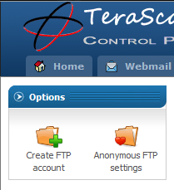
Click “Create FTP account” to add a new user. From there, you can select which folders this new user is able to access. If you want your user to only access one of your folders, and be blocked from the rest, use “Custom” and type in the path to the folder or domain name that they should be able to access.

Otherwise, use “Domain” to give this person full access to the domain you want them to be able to access.

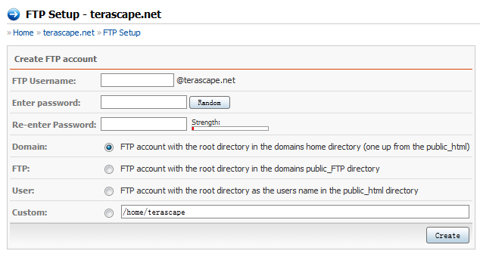

Databases

Database Management is found under "Databases". Most PHP applications, like Joomla, Drupal, phpBB & such use Databases. Use this to create your database and give yourself Admin privileges for installation purposes.

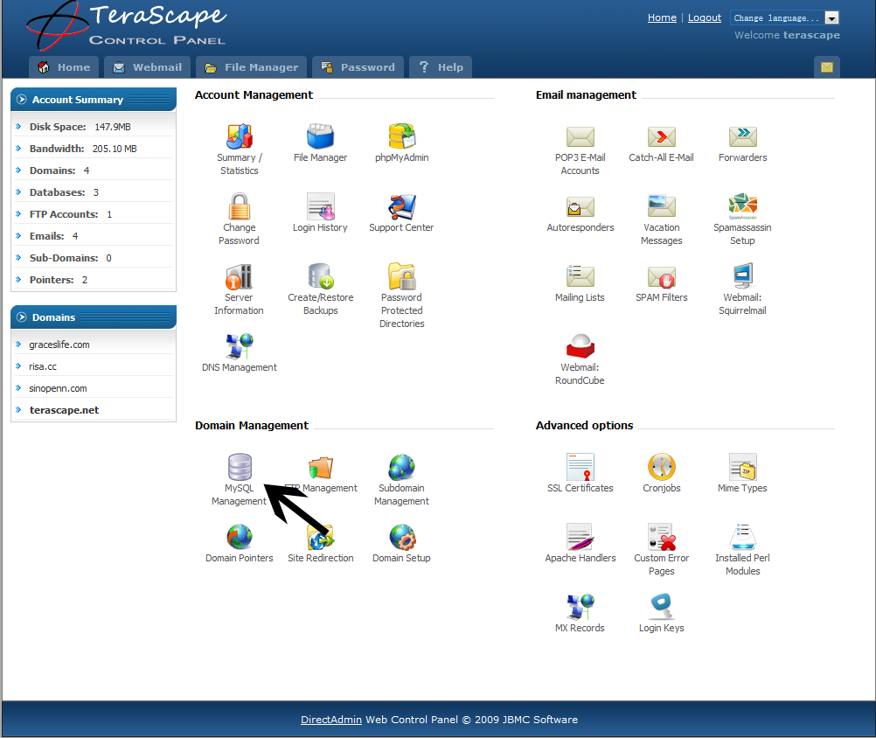

To Add a database, click the MySQL Management icon under “Domain Management” & click “Create New Database”.

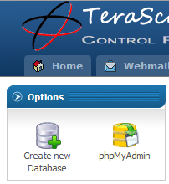
Add your database on the following fields:
Database Name:
Database Username:
Username Password:
Confirm Password:
Note: Do NOT use the same Username as the database name. If you already have a database Username, you can select “Use Existing” to automatically add the username and password to the new database.

phpMyAdmin
Click on the phpMyAdmin link to access your database and add, repair or delete tables. Alternatively, if you use a program like Navicat, a database management program, you’ll have to add a second Access Host. Just enter % & click “Add Host” and your database management program will be able to access your database.
